**QF600 (Asset Pricing) – Homework 5**

**Stochastic Discount Factor**

Suppose that consumption growth has lognormal distribution with the possibility of rare disasters:

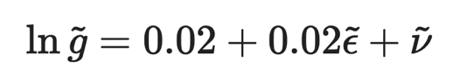

Here ε is a standard normal random variable, while ν is an independent random variable that has value of either zero (with probability of 98.3%) or ln(0.65) (with probability of 1.7%).

Simulate ε with (at least) 104 random draws from standard normal distribution, and simulate ν with (at least) 104 random draws from standard uniform distribution.

Use the simulated distribution of consumption growth to find the simulated distribution of the pricing kernel for power utility:

Repeat this process for values of γ in the range from 1 to 4, in increments of 0.1 (or less). (You can reuse the same simulated distribution of consumption growth for all values of γ)

1. Calculate the mean (μM) and standard deviation (σM) of pricing kernel for each value of γ, and plot the volatility ratio (σM/μM) on the vertical axis vs γ on the horizontal axis.

Answer:

|  |  |  |  |
| --- | --- | --- | --- |
| **Gamma (**γ) | **Volatility Ratio** (σM/μM) | **Mean of Pricing Kernel**  (μM) | **Standard Deviation of Pricing Kernel** (σM) |
| **1** | 0.07368 | 0.980148 | 0.072218 |
| **1.1** | 0.082717 | 0.979427 | 0.081016 |
| **1.2** | 0.09211 | 0.978761 | 0.090153 |
| **1.3** | 0.101872 | 0.978152 | 0.099647 |
| **1.4** | 0.11202 | 0.977601 | 0.109511 |
| **1.5** | 0.122569 | 0.977112 | 0.119763 |
| **1.6** | 0.133534 | 0.976686 | 0.13042 |
| **1.7** | 0.144931 | 0.976325 | 0.1415 |
| **1.8** | 0.156779 | 0.976033 | 0.153021 |
| **1.9** | 0.169094 | 0.975811 | 0.165004 |
| **2** | 0.181894 | 0.975663 | 0.177467 |
| **2.1** | 0.195197 | 0.97559 | 0.190433 |
| **2.2** | 0.209023 | 0.975597 | 0.203923 |
| **2.3** | 0.223391 | 0.975685 | 0.21796 |
| **2.4** | 0.238321 | 0.975858 | 0.232568 |
| **2.5** | 0.253833 | 0.97612 | 0.247772 |
| **2.6** | 0.269948 | 0.976474 | 0.263597 |
| **2.7** | 0.286688 | 0.976922 | 0.280072 |
| **2.8** | 0.304074 | 0.97747 | 0.297224 |
| **2.9** | 0.322129 | 0.97812 | 0.315081 |
| **3** | 0.340876 | 0.978878 | 0.333676 |
| **3.1** | 0.360337 | 0.979746 | 0.353039 |
| **3.2** | 0.380537 | 0.98073 | 0.373204 |
| **3.3** | 0.401499 | 0.981833 | 0.394205 |
| **3.4** | 0.423248 | 0.983062 | 0.416079 |
| **3.5** | 0.445808 | 0.98442 | 0.438862 |
| **3.6** | 0.469205 | 0.985912 | 0.462595 |
| **3.7** | 0.493464 | 0.987545 | 0.487318 |
| **3.8** | 0.51861 | 0.989324 | 0.513073 |
| **3.9** | 0.544669 | 0.991254 | 0.539905 |
| **4** | 0.571666 | 0.993342 | 0.56786 |

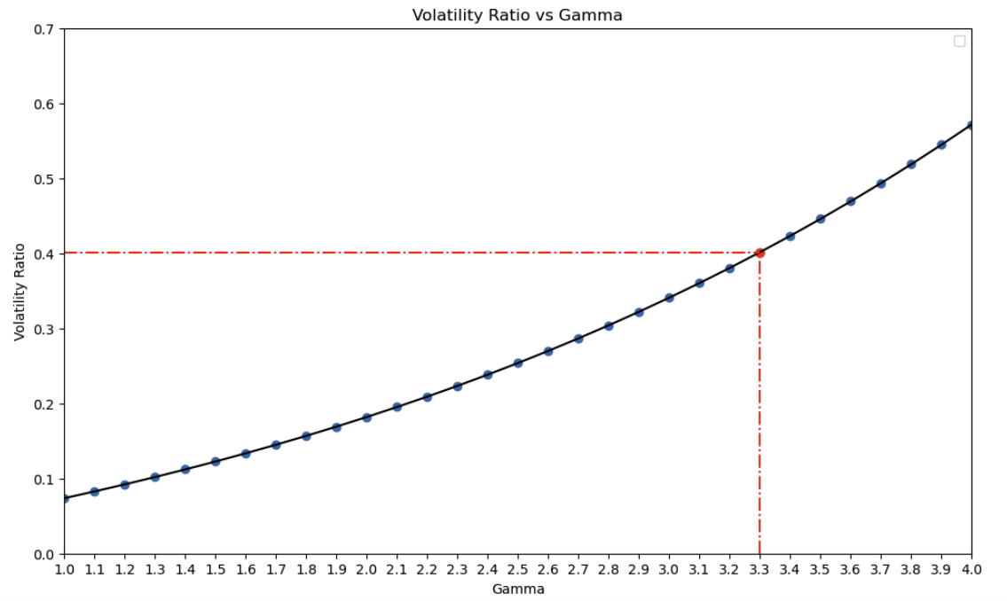

Figure 1.

1. Find the smallest value of γ (in your data) for which σM/μM > 0.4. Explain (in words, without using mathematical equations or formulas) the economic significance of this result.

Answer:

**Part 1:**

The smallest value of γ for which σM/μM > 0.4 is 3.3.

Based on:

* σM/μM = 0.4 (which is the Sharpe ratio for the US stock market)
* Robert Barro’s estimated p = 1.7% and f = 0.65, based on survey of major disasters of 20th century.

Investors with power utility must have a lower bound degree of relative risk aversion (γ) >= 3.3 to satisfy Hansen-Jagannathan (H-J) bound. This minimum γ value represents the required degree of risk aversion for investors to demand sufficient compensation for holding risky assets in line with real market condition.

**Part 2:**

*a. Equity Premium Puzzle*

When we’re using the Hansen-Jagannathan (H-J) bound, without random variables that account for rare disasters, γ >= 20, which is an unreasonably high degree of relative risk aversion. In this case, there is equity premium puzzle, where investors with time-separable power utility of consumption and lognormal consumption growth must have unreasonably high degree of relative risk aversion. Such high degree of risk aversion means that investors are too sensitive to risk, which contradicts the stable consumption growth observed in practice. Risk aversion magnifies the volatility of consumption growth, so must have a high degree of risk aversion since consumption growth is very stable but pricing kernel is very volatile. This model then suggests that either investors don’t have power utility of consumption, or consumption growth doesn’t have lognormal distribution.

In terms of the skewness bound, the investor’s optimal consumption growth has lognormal distribution, in which there is only a small amount of negative (left) skewness. Hence, for investors with power utility of consumption, distribution for pricing kernel will have positive skewness that increases with investor’s relative risk aversion. Empirical evidence suggests that probability distribution for pricing kernel should have large amount of positive skewness, hence investors must also have high degree of relative risk aversion to satisfy this ‘skewness bound’ for the pricing kernel. However, the empirical data on post-war consumption understates volatility and skewness of consumption growth, and can be integrated in the model by having a possibility of rare disasters.

*b. Rare Disaster (No Equity Premium Puzzle)*

When taking into account the possibility of rare disasters, as done in the first part (shown in Figure 1), the lower bound of the degree or relative risk aversion reduces to around 3.3, which is much more reasonable than γ >= 20. By assuming that optimal consumption growth also contains random variable that represents effects of rare disaster, we don’t severely understate the amount of negative (left) skewness, and hence solving the equity premium puzzle of having a very high degree of relative risk aversion. This is because the intuition is that rare disasters greatly increases volatility and negative (left) skewness of consumption growth, so we only need a small amount of magnification (via γ) to match volatility and negative (left) skewness of pricing kernel. With a sensible lower bound for γ, now the equity premium puzzle is solved.